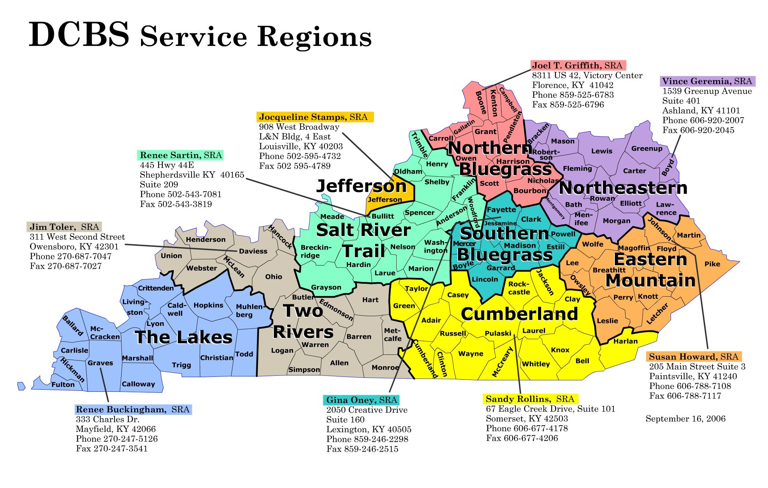

BCLERK13Bell, Harlan, Knox, WhitleyClay, Jackson, Laurel, Rockcastle,  **Phone:** 606-546-6527

BCLERK14Adair, Casey, Clinton, Cumberland, Green, McCreary, Pulaski, Russell, Taylor, Wayne

**Phone:** 270-465-3549

BCLERK 6DFayette A-J

**Phone:** 859-246-2070

BCLERK15EFayette K-Z

**Phone:** 859-246-2070

BCLERK17D  
Mercer, Bourbon, Garrard, Jessamine, Lincoln, Madison, Boyle, Clark, Estill, Powell

**Phone:** 859-239-7105

BCLERK2A  
Caldwell, Christian, Crittenden, Hopkins, Livingston, Lyon, Muhlenberg, Todd, Trigg

**Phone:** 270-889-6573

BCLERK2Ballard, Calloway, Carlisle, Fulton, Graves, Hickman, Marshall, McCracken

**Phone:** 270-247-2900

BCLERK13AB Boyd, Carter, Elliott, Greenup, Lawrence

**Phone:** 606-920-2007

BCLERK10ABath, Bracken, Fleming, , Lewis, Mason, Robertson, Rowan, Menifee, Montgomery, Morgan

**Phone:** 606-920-2007

BCLERK6F  
Foster Homes/Vendors (A-L),  
Adoptive Homes (A-K)

**Phone:** 502-595-4680

BCLERK5AFoster Homes/Vendors (M-Z)Adoptive Homes (Sc-Z)

**Phone:** 502-595-4422

BCLERK16Jefferson PCCsAdoptive Homes (L-Sa)

**Phone:** 502-647-9245

BCLERK3A

Franklin, Woodford, Breckenridge, Grayson, Washington

**Phone:** 270-766-5192

BCLERK15D  
Anderson, Nelson

**Phone:** 270-766-5192

BCLERK16ABullitt, Henry, Oldham, Shelby, Spencer, Trimble

**Phone:** 502-222-9472

**DCBS/DAFM  
Billing Specialists**

**Central Office-**502/564-3427

BCLERK 1CFloyd, Johnson, Magoffin, Martin, Pike

**Phone:** 606-788-7108

BCLERK11BBreathitt, Knott, Lee, Leslie, Letcher, Owsley, Perry, Wolfe **Phone:** 606-435-6052

BCLERK7CDCBS Foster Home

**Phone:** 859-525-6783

BCLERK11PCCsBoone, Campbell, Carroll, Gallatin, Grant, Kenton, Owen, Pendleton, Harrison, Nicholas

**Phone:** 859-525-6783

BCLERK3Daviess, Hancock, Henderson, McLean, Ohio, Union, Webster

**Phone:** 270-687-7047

BCLERK3BButler, Edmonson, Hart, Logan, Simpson, Warren

**Phone:** 270-687-7047